1. Write a script called mycase, using the case utility to checks the type of character
entered by a user:
a. Upper Case.
b. Lower Case.
c. Number.
d. Nothing.
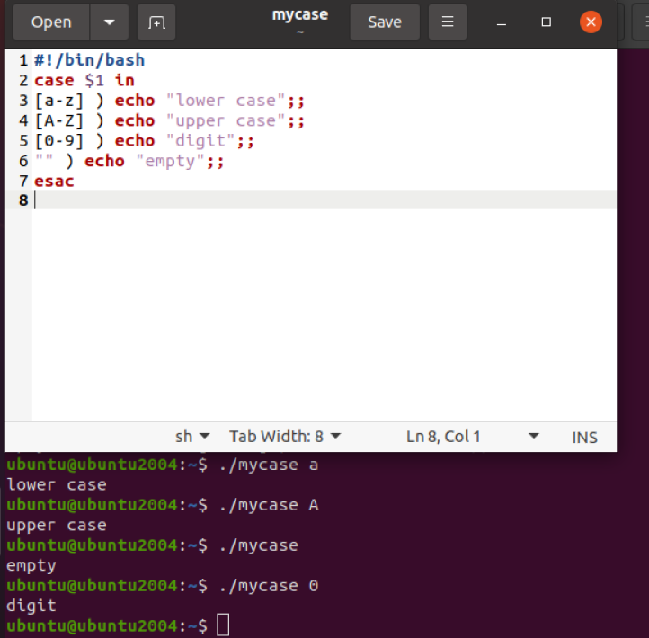

2. Enhanced the previous script, by checking the type of string entered by a user:
a. Upper Cases.
b. Lower Cases.
c. Numbers.
d. Mix.
e. Nothing.
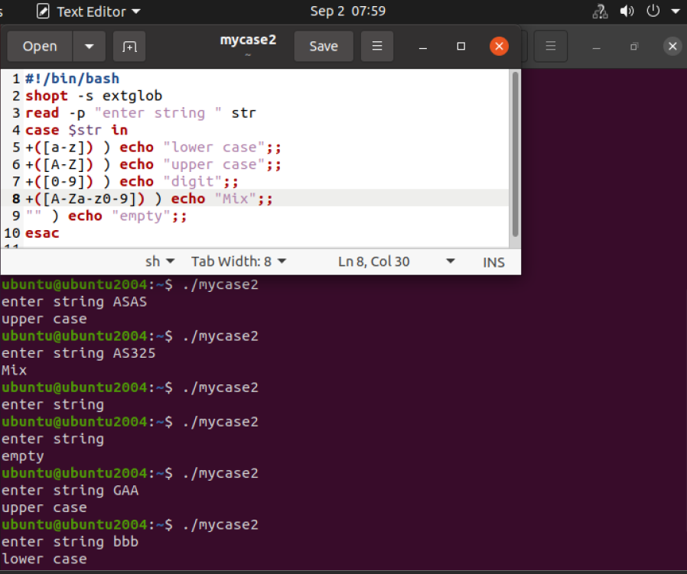

3. Write a script called mychmod using for utility to give execute permission to all files and
directories in your home directory.
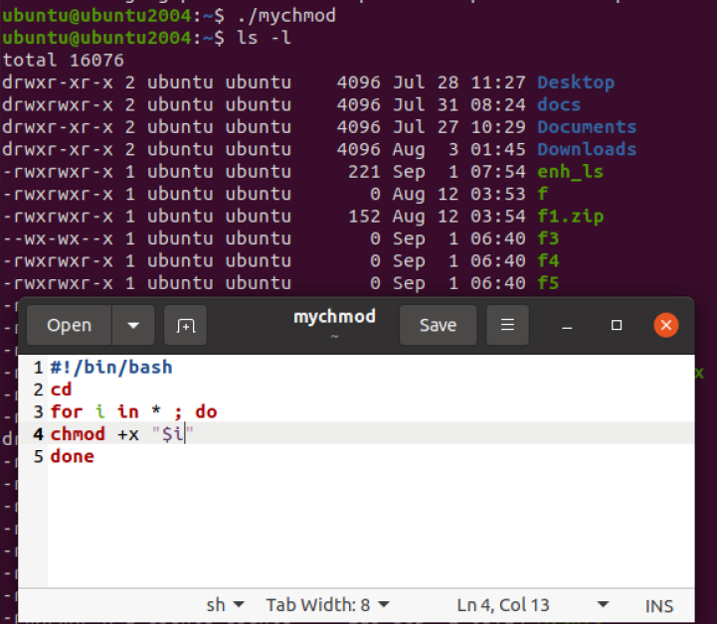

4. Write a script called mybackup using for utility to create a backup of only files in your
home directory.
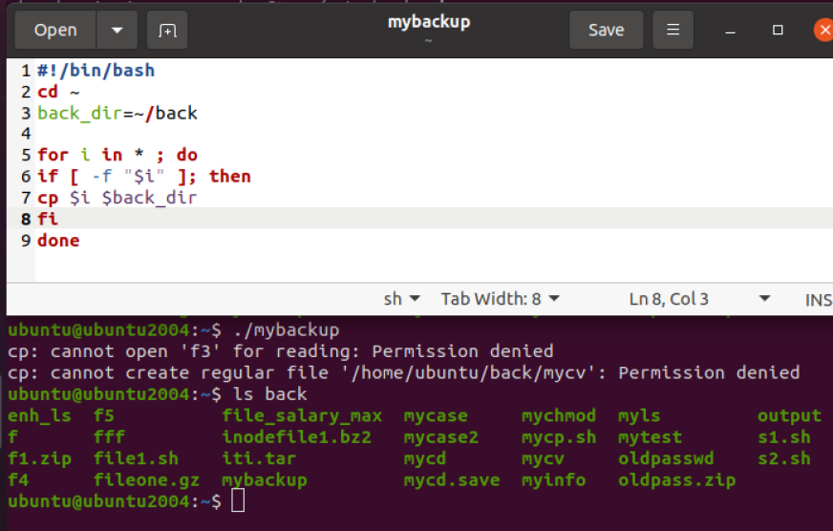
5. Write a script called mymail using for utility to send a mail to all users in the system.
Note: write the mail body in a file called mtemplate.
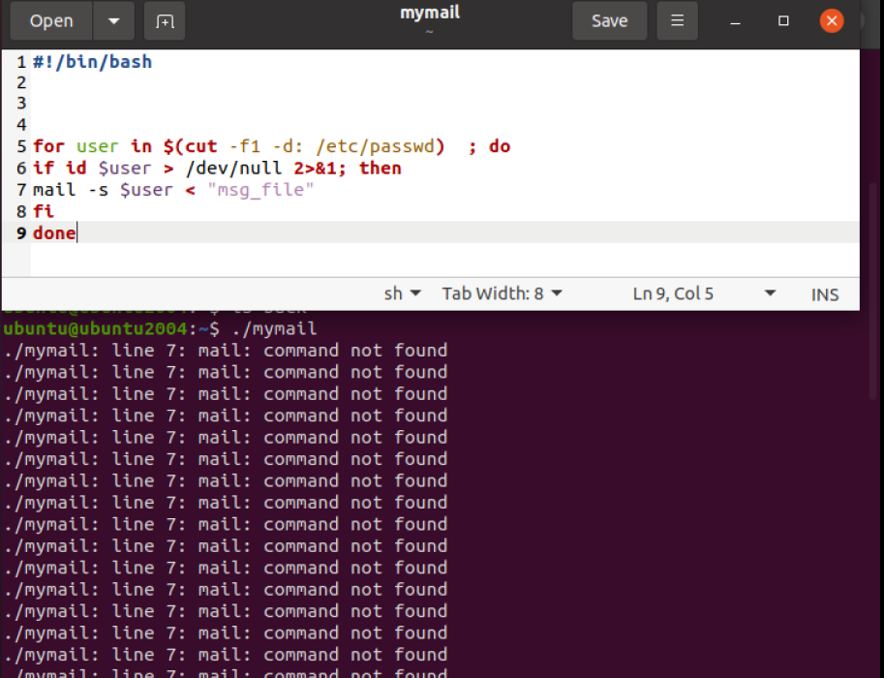
6. Write a script called chkmail to check for new mails every 10 seconds. Note: mails are
saved in /var/mail/username.

Bonus:
Open a talk session to a certain user when she/he logs into the system.

7. What is the output of the following script
typeset –i n1
typeset –i n2
n1=1
n2=1
while test $n1 –eq $n2
do
n2=$n2+1
print $n1
if [ $n1 –gt $n2 ]
then
break
else
continue
fi
n1=$n1+1
print $n2
done

output : 1 as we enter else (continue ) and returned to while condition
that is false

8. Create the following menu:
a. Press 1 to ls
b. Press 2 to ls –a
c. Press 3 to exit
Using select utility then while utility.
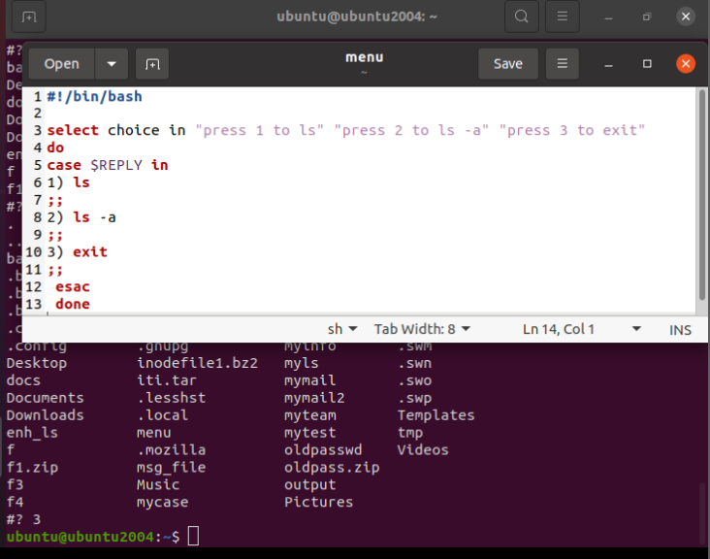

9. Write a script called myarr that ask a user how many elements he wants to enter in an
array, fill the array and then print it.
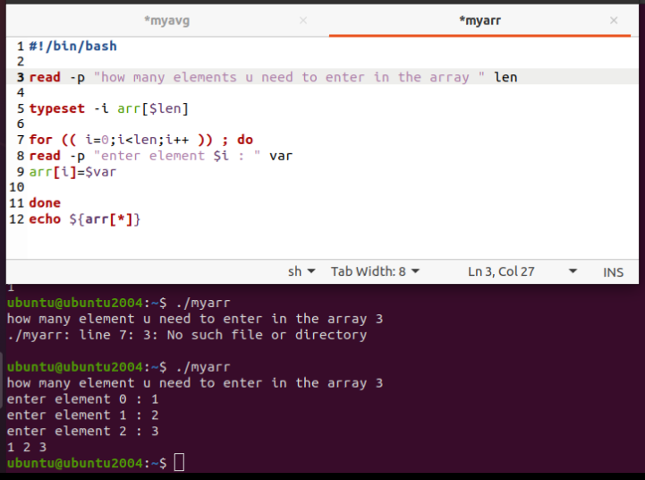
10.Write a script called myavg that calculate average of all numbers entered by a user.
Note: use arrays
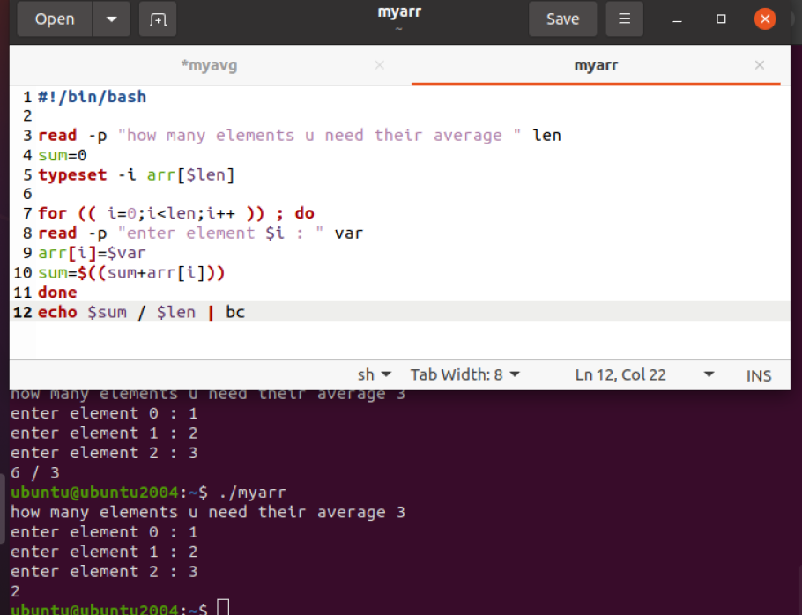
11.Write a function called mysq that calculate square if its argument.
